NETWORK LOAD BALANCER-

Network load balancer donot has the hands on lab due to it’s very difficult to handle so in exam its theoretical knowledge is necessary how we use this service. Just follow the screenshot or see the ppt for the referece in the stephens resources

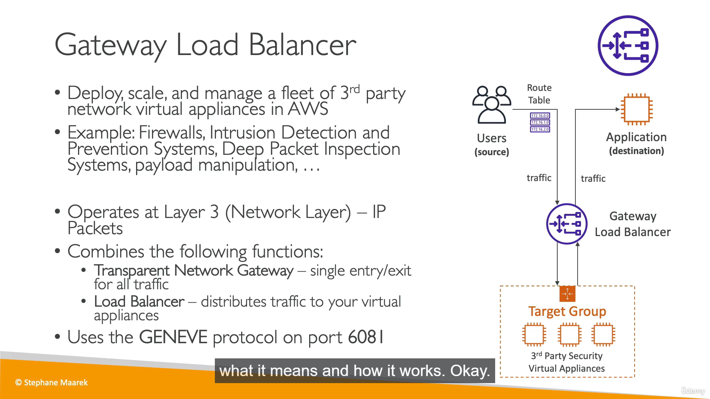Right Hand side diagram is sufficient how the NLB works.